**727721EUIT023 – CHARUKEAS T**

**Software Testing using Selenium**

**Coding Contest - 1**

1.Code:

package com.selenium.cia1.selenium;

import org.openqa.selenium.By;

import org.openqa.selenium.WebDriver;

import org.openqa.selenium.WebElement;

import org.openqa.selenium.chrome.ChromeDriver;

import org.openqa.selenium.chrome.ChromeOptions;

import io.github.bonigarcia.wdm.WebDriverManager;

public class CC_Qn_1 {

public static void main(String args[]) throws InterruptedException{

WebDriverManager.chromedriver().setup();

ChromeOptions co = new ChromeOptions();

co.addArguments("--remote-allow-origins=*");

WebDriver driver = new ChromeDriver(co);

driver.manage().window().maximize();

driver.get("https://www.saucedemo.com/");

WebElement user = driver.findElement(By.id("user-name"));

WebElement pass = driver.findElement(By.id("password"));

WebElement submit = driver.findElement(By.id("login-button"));

user.sendKeys("standard_user");

pass.sendKeys("secret_sauce");

submit.click();

WebElement addToCart = driver.findElement(By.id("add-to-cart-sauce-labs-backpack"));

addToCart.click();

String count = driver.findElement(By.id("remove-sauce-labs-backpack")).getText();

if(count.equals("Remove")) {

System.out.println("Product added to Cart successfully");

}else {

System.out.println("Product not added to Cart");

}

WebElement cart = driver.findElement(By.xpath("//*[@id=\"shopping_cart_container\"]/a"));

cart.click();

String product = driver.findElement(By.xpath("//*[@id=\"item_4_title_link\"]/div")).getText();

if(product.equals("Sauce Labs Backpack")) {

System.out.println("Product is viewable in the Cart");

}else {

System.out.println("Product is not viewable in the Cart");

}

driver.findElement(By.id("checkout")).click();

String checkout = driver.findElement(By.xpath("//*[@id=\"header_container\"]/div[2]/span")).getText();

if(checkout.equals("Checkout: Your Information")) {

System.out.println("Your information form is displayed");

}else {

System.out.println("Ypur information form is not displayed");

}

driver.findElement(By.id("first-name")).sendKeys("Charu");

driver.findElement(By.id("last-name")).sendKeys("Keys");

driver.findElement(By.id("postal-code")).sendKeys("626130");

driver.findElement(By.id("continue")).click();

String formFilled = driver.findElement(By.xpath("//*[@id=\"header_container\"]/div[2]/span")).getText();

if(formFilled.equals("Checkout: Overview")) {

System.out.println("Product overview is displayed");

}else {

System.out.println("Product overview is not displayed");

}

String name = driver.findElement(By.xpath("//*[@id=\"item_4_title_link\"]/div")).getText();

String price = driver.findElement(By.xpath("//*[@id=\"checkout_summary_container\"]/div/div[1]/div[3]/div[2]/div[2]/div")).getText();

System.out.println("Name : " + name);

System.out.println("Price : " + price);

String title = driver.getTitle();

if(title.equals("Swag Labs")) {

System.out.println("Asserted the title of the page");

}else {

System.out.println("The title of the page is not matching");

}

String url = driver.getCurrentUrl();

if(url.equals("https://www.saucedemo.com/checkout-step-two.html")) {

System.out.println("Asserted the URL of the page");

}else {

System.out.println("The URL of the page is not matching");

}

}

}

ScreenShots:

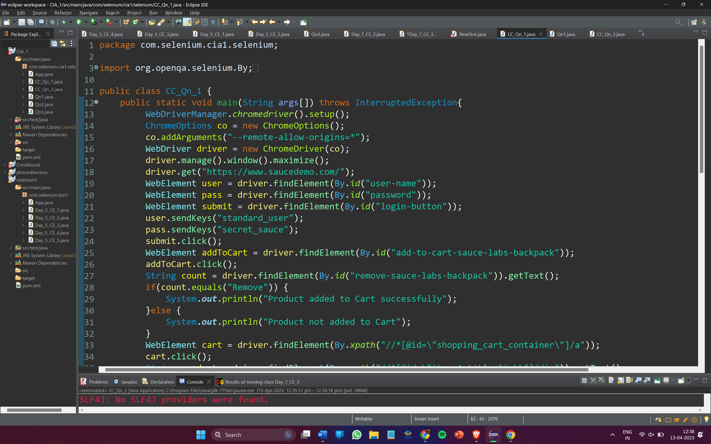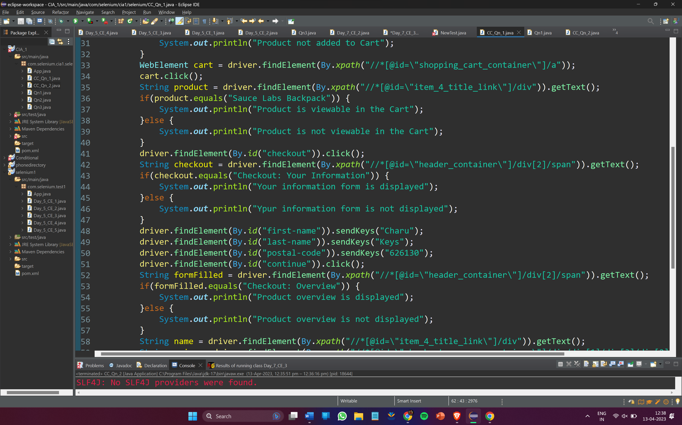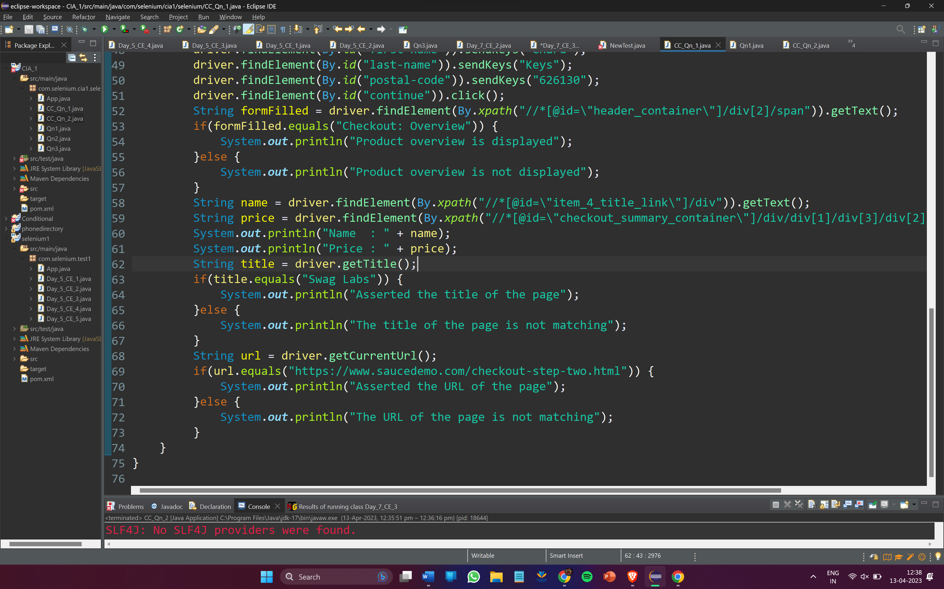

Output:

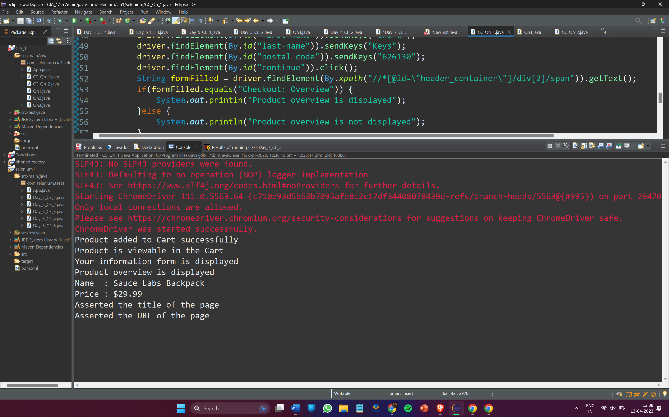

2.Code:

package com.selenium.cia1.selenium;

import org.openqa.selenium.By;

import org.openqa.selenium.WebDriver;

import org.openqa.selenium.WebElement;

import org.openqa.selenium.chrome.ChromeDriver;

import org.openqa.selenium.chrome.ChromeOptions;

import org.openqa.selenium.support.ui.Select;

import io.github.bonigarcia.wdm.WebDriverManager;

public class CC_Qn_2{

public static void main(String args[]) throws InterruptedException{

WebDriverManager.*chromedriver*().setup();

ChromeOptions co = new ChromeOptions();

co.addArguments("--remote-allow-origins=*");

WebDriver driver = new ChromeDriver(co);

driver.manage().window().maximize();

driver.get("https://www.saucedemo.com/");

WebElement user = driver.findElement(By.*id*("user-name"));

WebElement pass = driver.findElement(By.*id*("password"));

WebElement submit = driver.findElement(By.*id*("login-button"));

user.sendKeys("standard_user");

pass.sendKeys("secret_sauce");

submit.click();

WebElement drop = driver.findElement(By.*className*("product_sort_container"));

drop.click();

Select select= new Select(drop);

select.selectByVisibleText("Name (A to Z)");

Thread.*sleep*(4000);

WebElement pro1=driver.findElement(By.*xpath*("//*[@id=\"header_container\"]/div[2]/div/span/select/option[1]"));

if(pro1.getText().equals("Name (A to Z)")) {

System.***out***.println("Able to apply filter A-Z");

}

Thread.*sleep*(4000);

pro1.click();

WebElement prod1=driver.findElement(By.*xpath*("//*[@id=\"item_4_title_link\"]/div"));

System.***out***.println("First product name while filtering from A-Z :-"+prod1.getText());

WebElement pro2=driver.findElement(By.*xpath*("//*[@id=\"header_container\"]/div[2]/div/span/select/option[2]"));

if(pro2.getText().equals("Name (Z to A)")) {

System.***out***.println("Able to apply filter Z-A");

}

pro2.click();

Thread.*sleep*(4000);

WebElement prod2=driver.findElement(By.*xpath*("//*[@id=\"item_3_title_link\"]/div"));

System.***out***.println("First product name while filtering from Z-A :-"+prod2.getText());

WebElement pro3=driver.findElement(By.*xpath*("//*[@id=\"header_container\"]/div[2]/div/span/select/option[3]"));

if(pro3.getText().equals("Price (low to high)")) {

System.***out***.println("Able to apply filter Low-High");

}

pro3.click();

Thread.*sleep*(4000);

WebElement prod3=driver.findElement(By.*xpath*("//*[@id=\"item_2_title_link\"]/div"));

System.***out***.println("First product name while filtering from Price (low to high) :-"+prod3.getText());

WebElement pro4=driver.findElement(By.*xpath*("//*[@id=\"header_container\"]/div[2]/div/span/select/option[4]"));

if(pro4.getText().equals("Price (high to low)")) {

System.***out***.println("Able to apply filter High-Low");

}

pro4.click();

Thread.*sleep*(4000);

WebElement prod4=driver.findElement(By.*xpath*("//*[@id=\"item_5_title_link\"]/div"));

System.***out***.println("First product name while filtering from Price (high to low) :-"+prod4.getText());

}

}

ScreenShots:

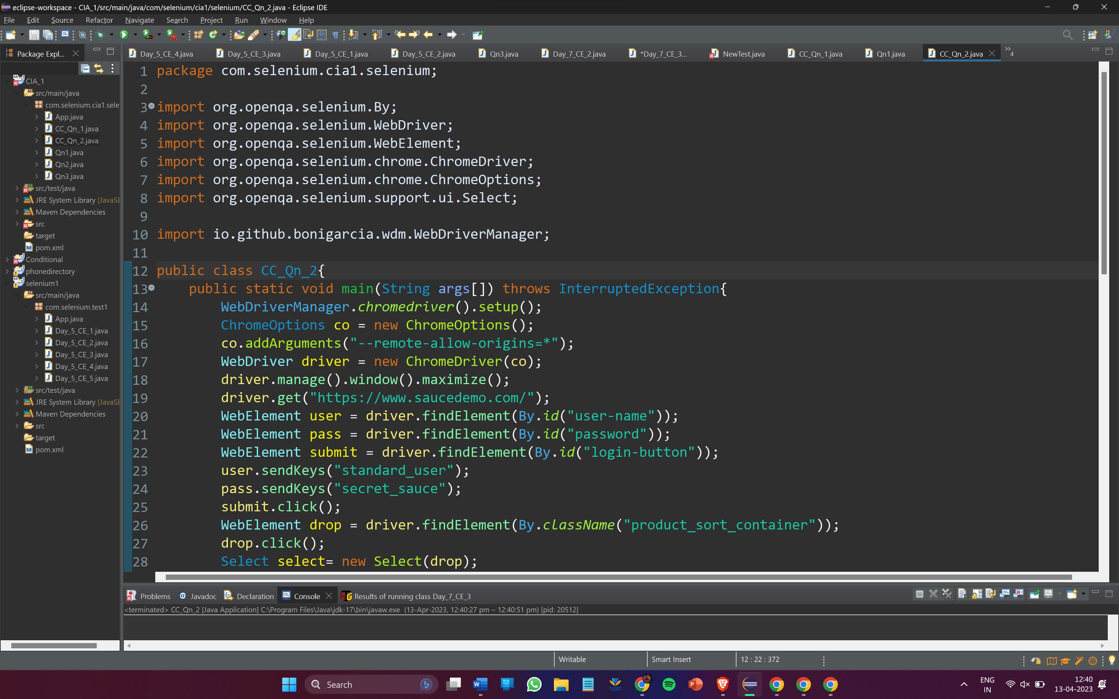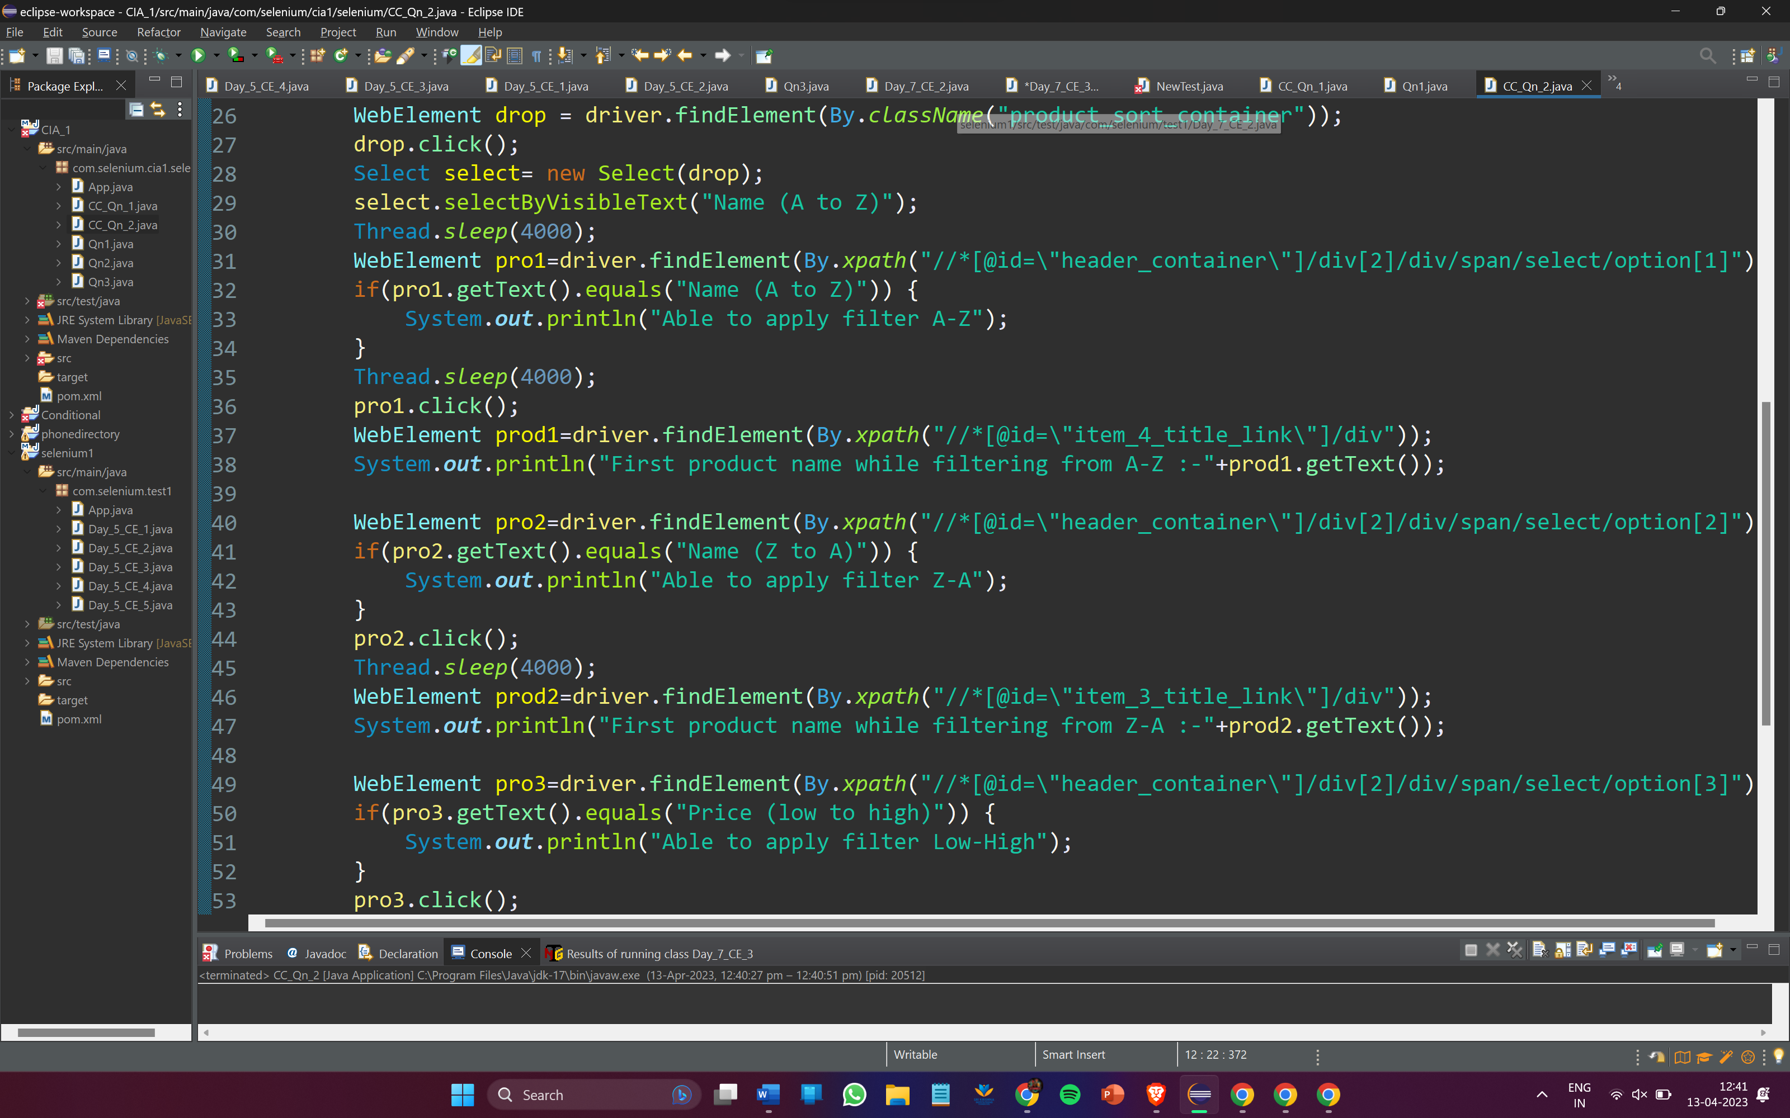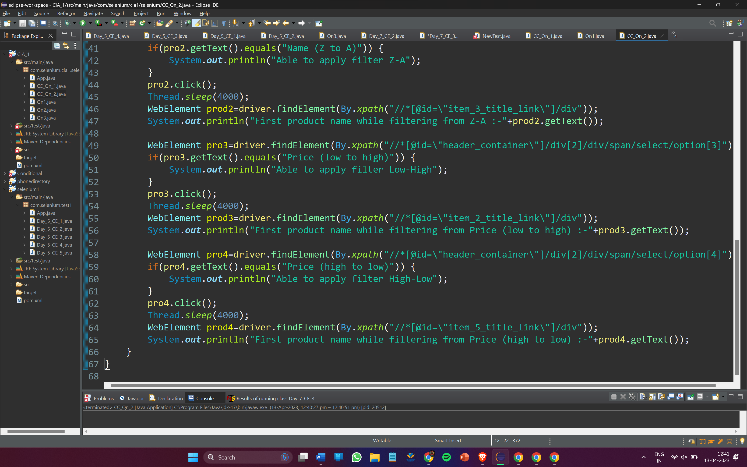Output:

